**CS8711 –CLOUD COMPUTING LABORATORY**

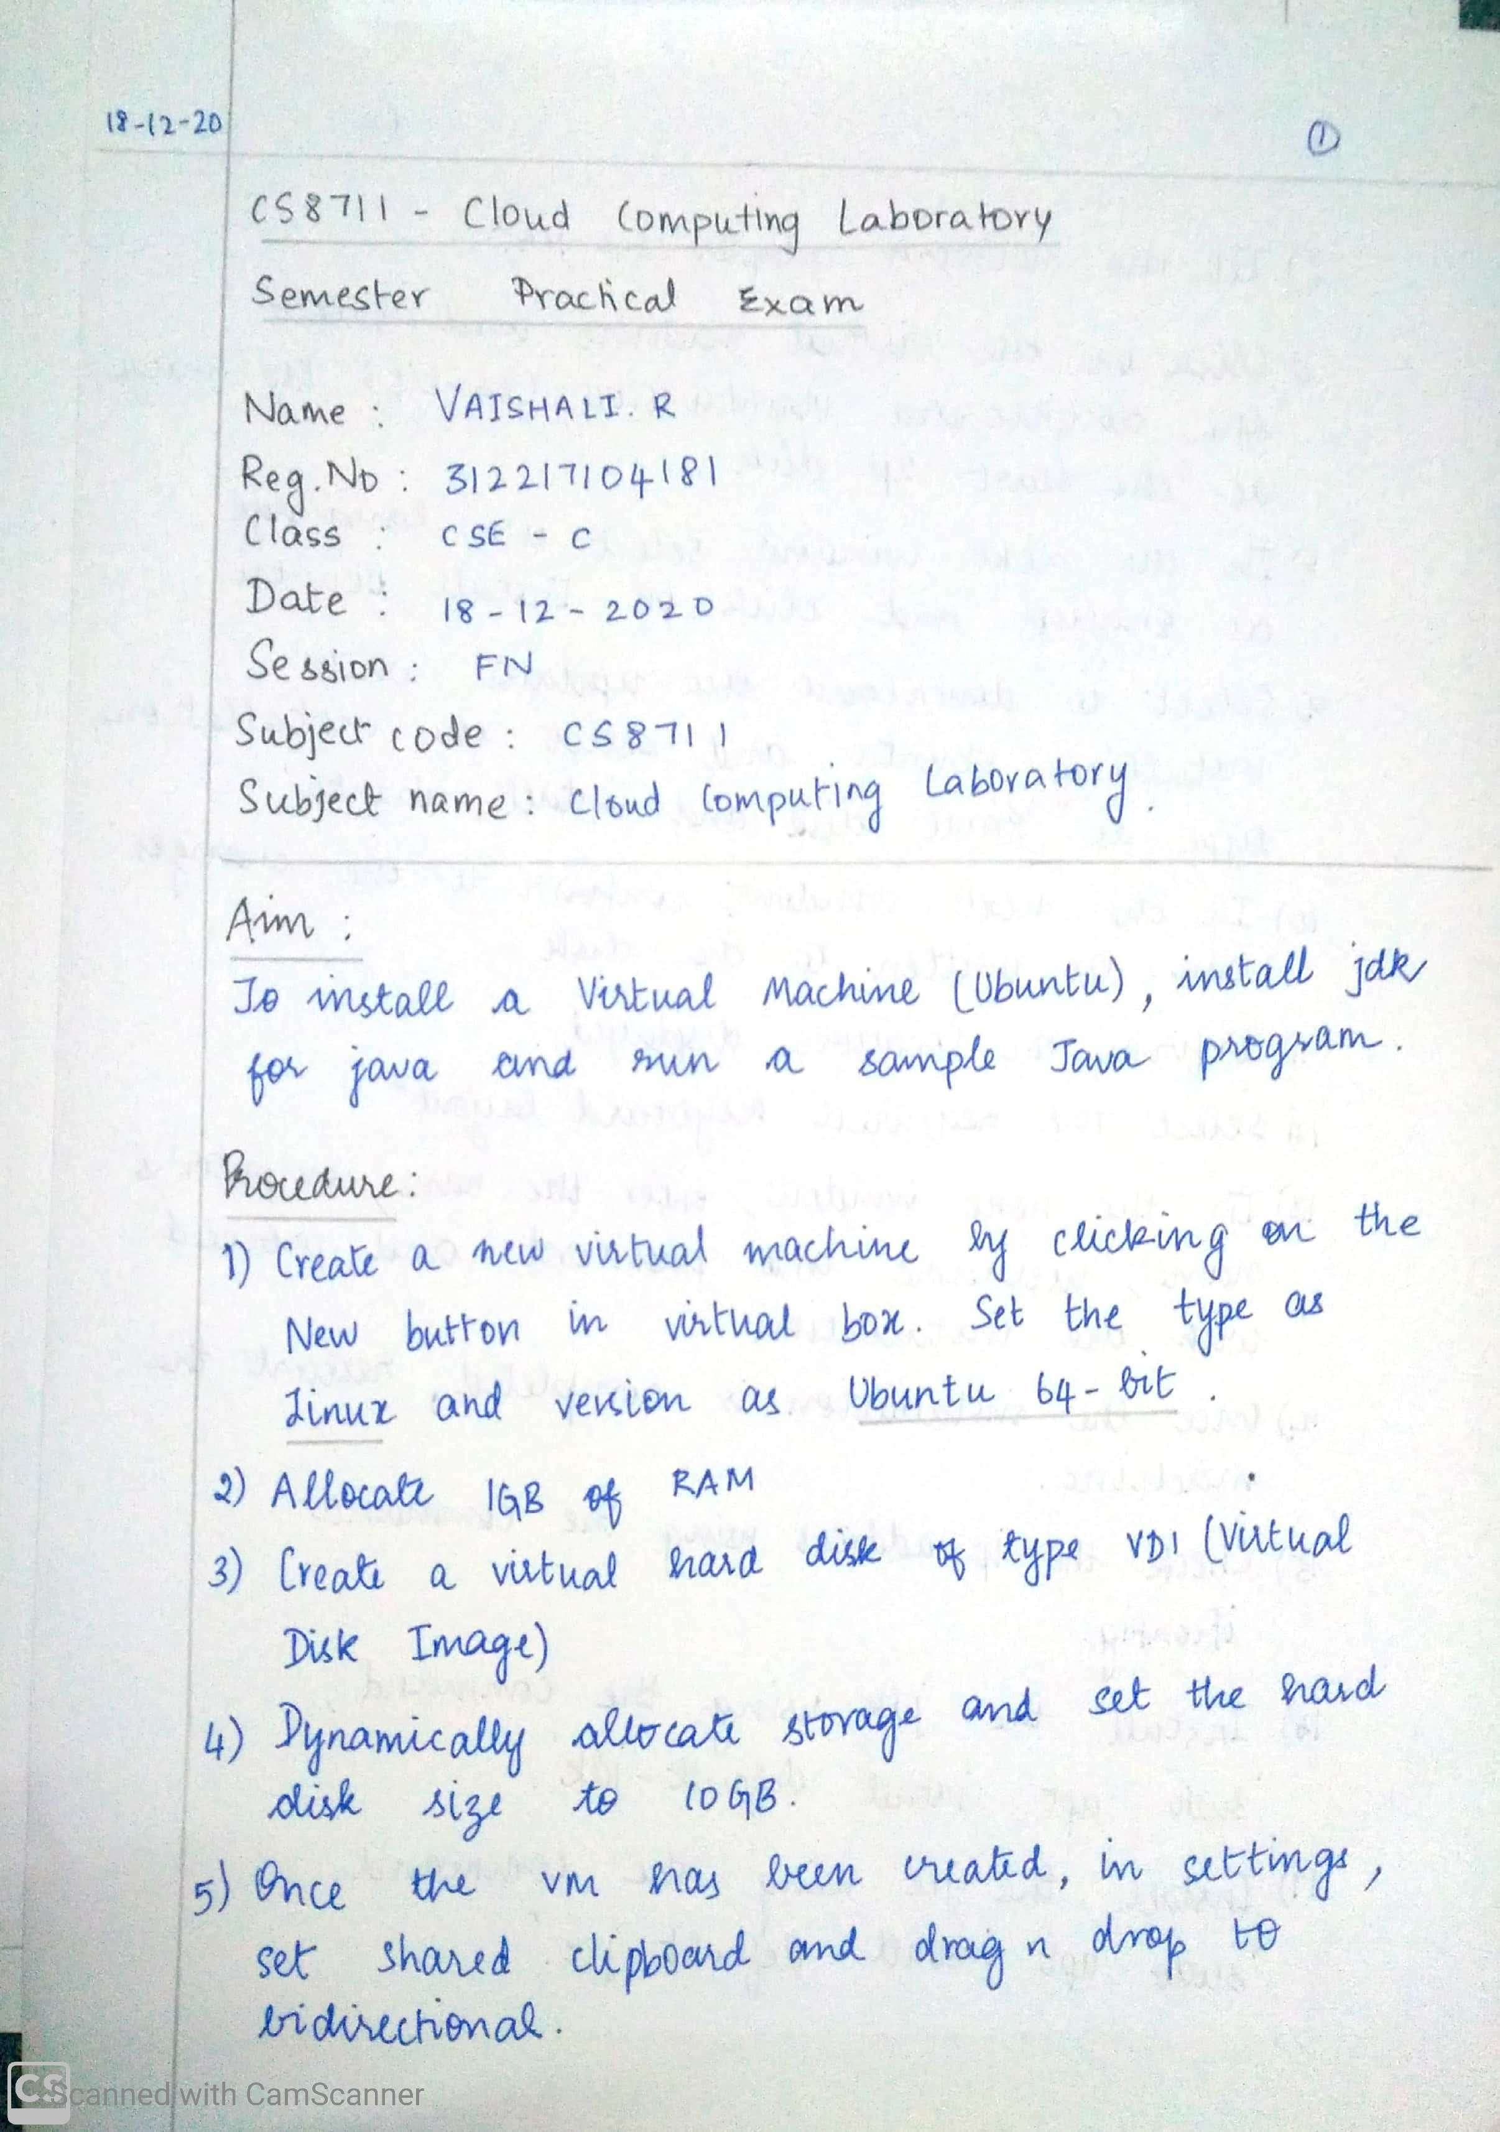

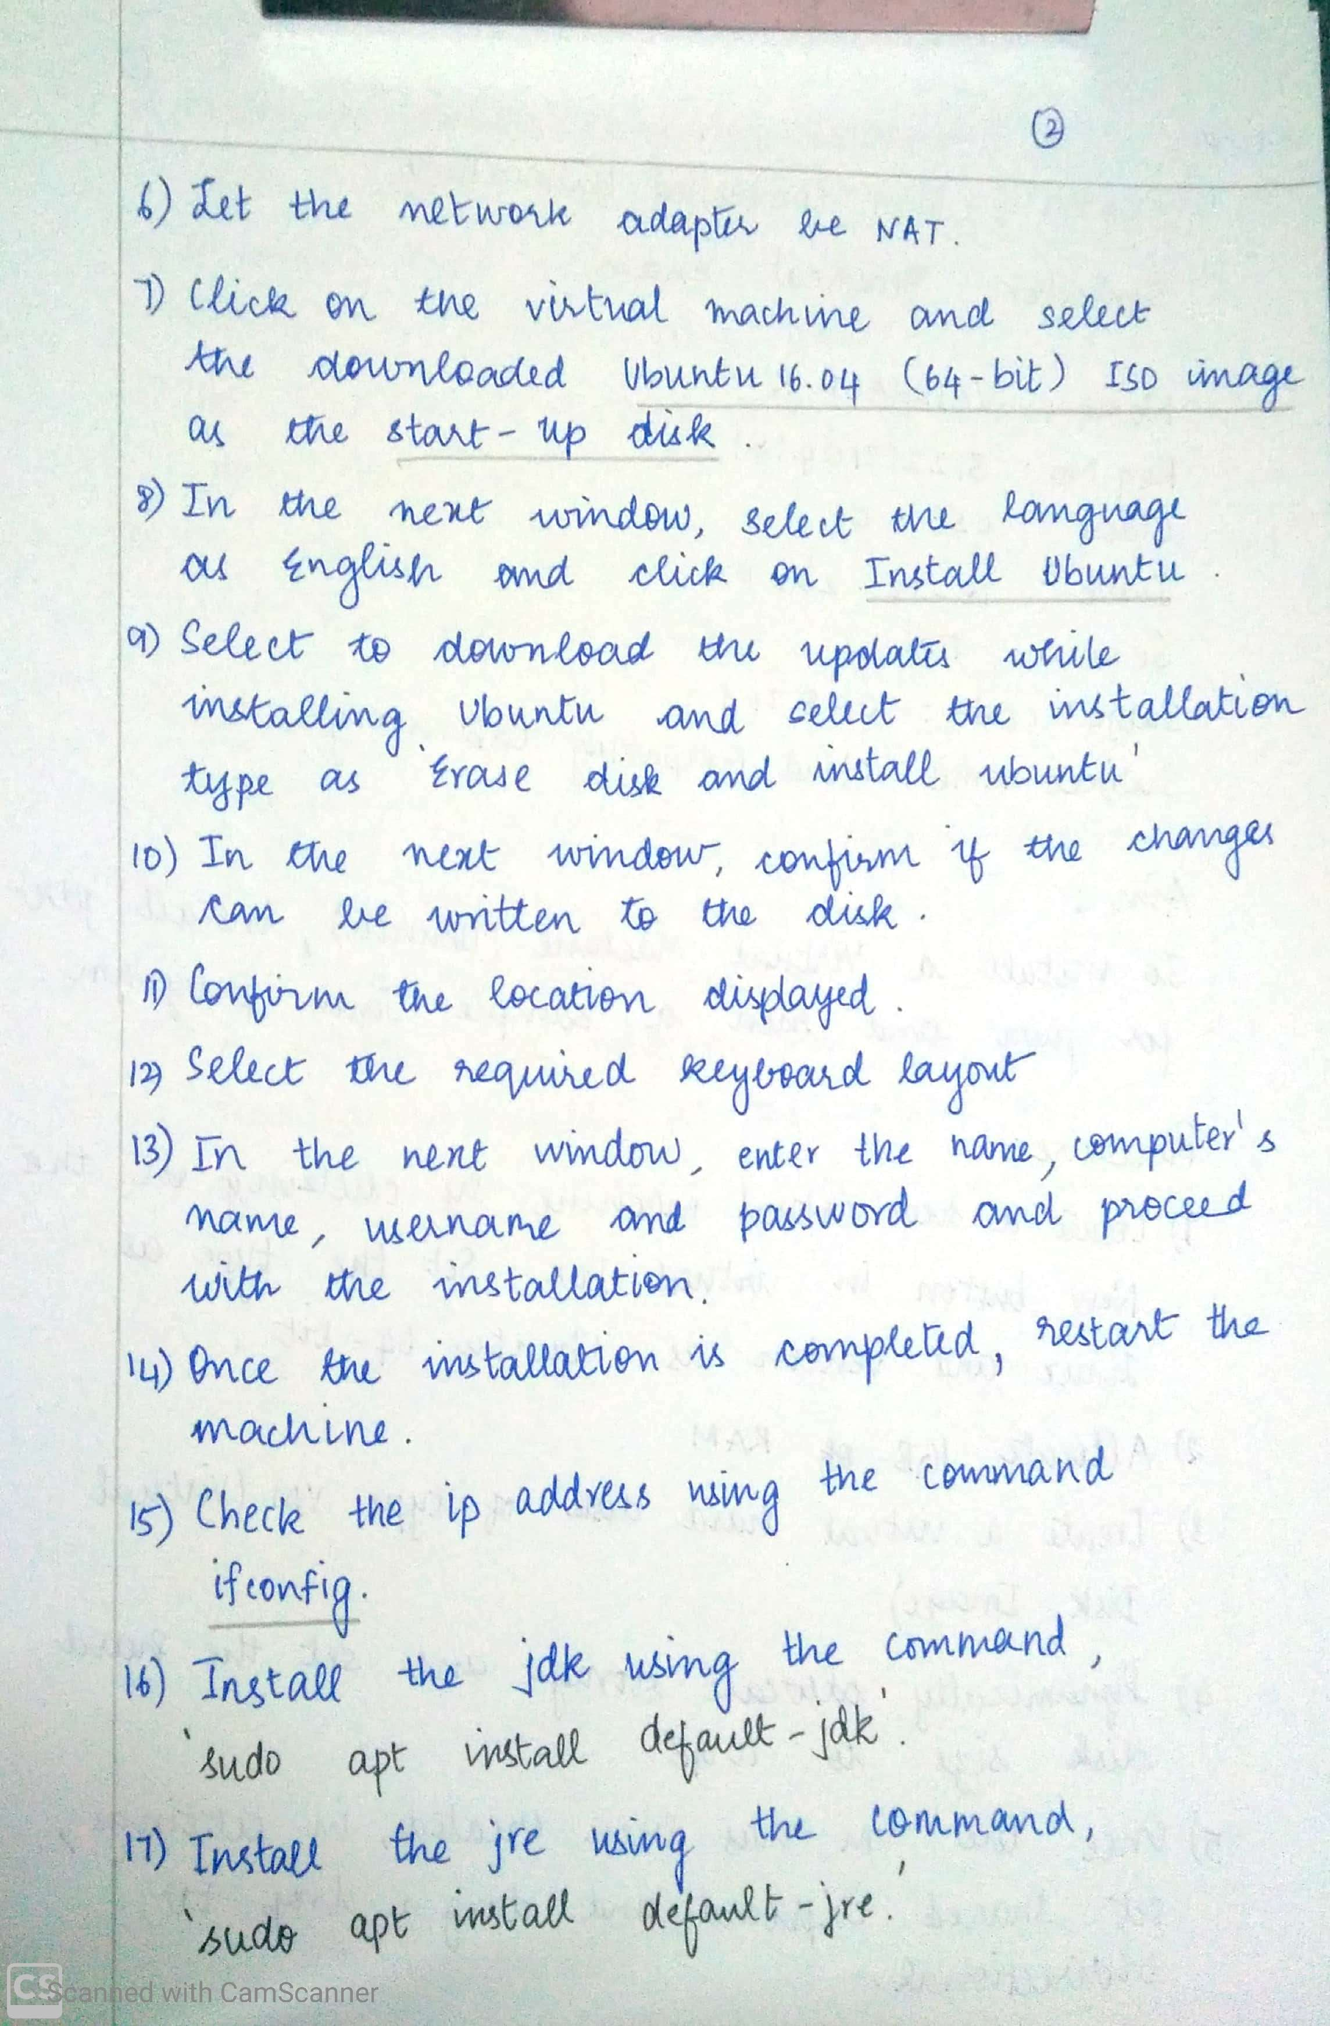

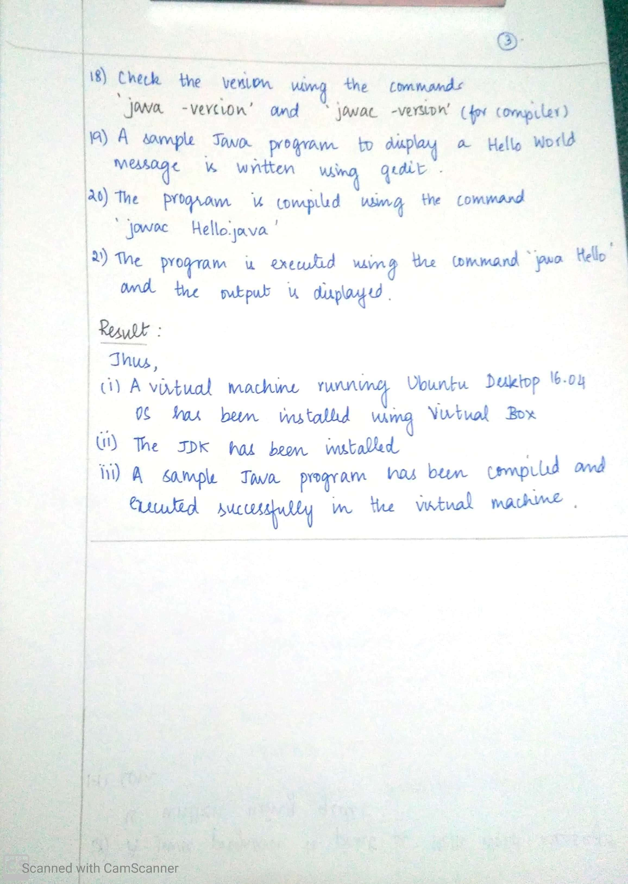

**OUTPUT SCREENSHOTS:**

**STEP 1:** Create a new virtual machine (Ubuntu desktop 16.04)

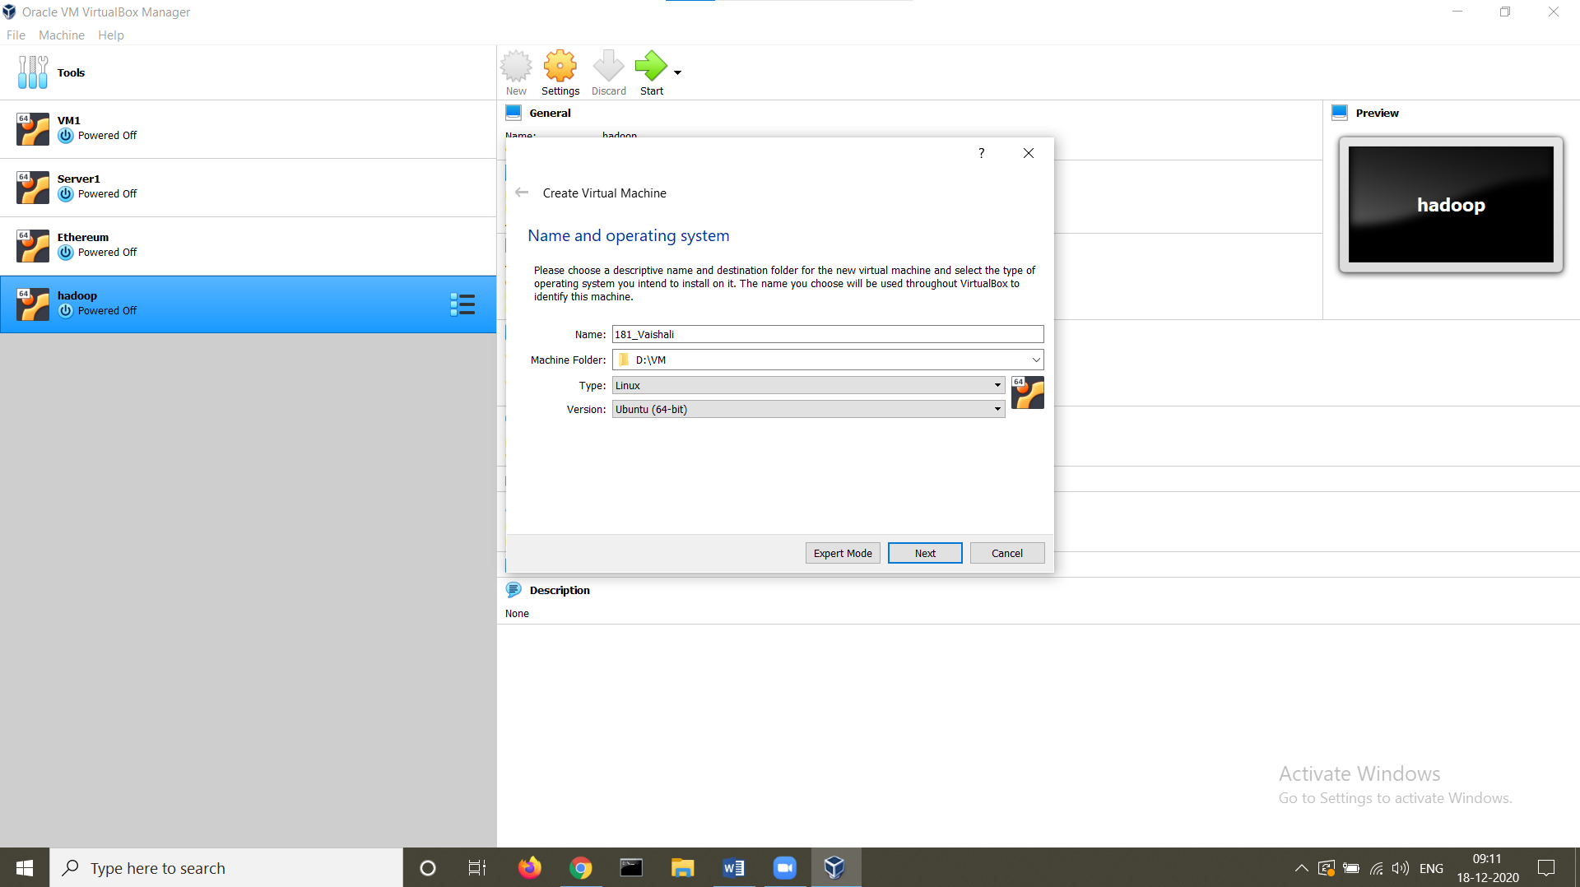

**STEP 2:** Allocate 1GB of RAM

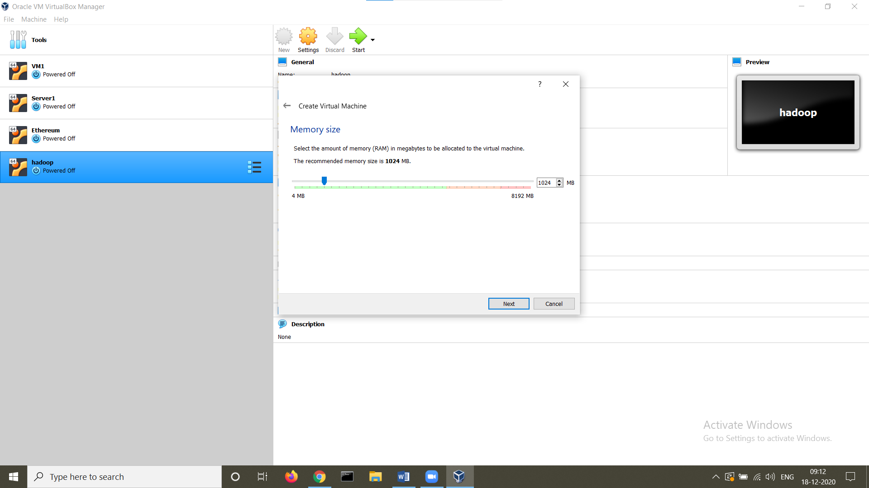

**STEP 3:** Create a virtual hard disk

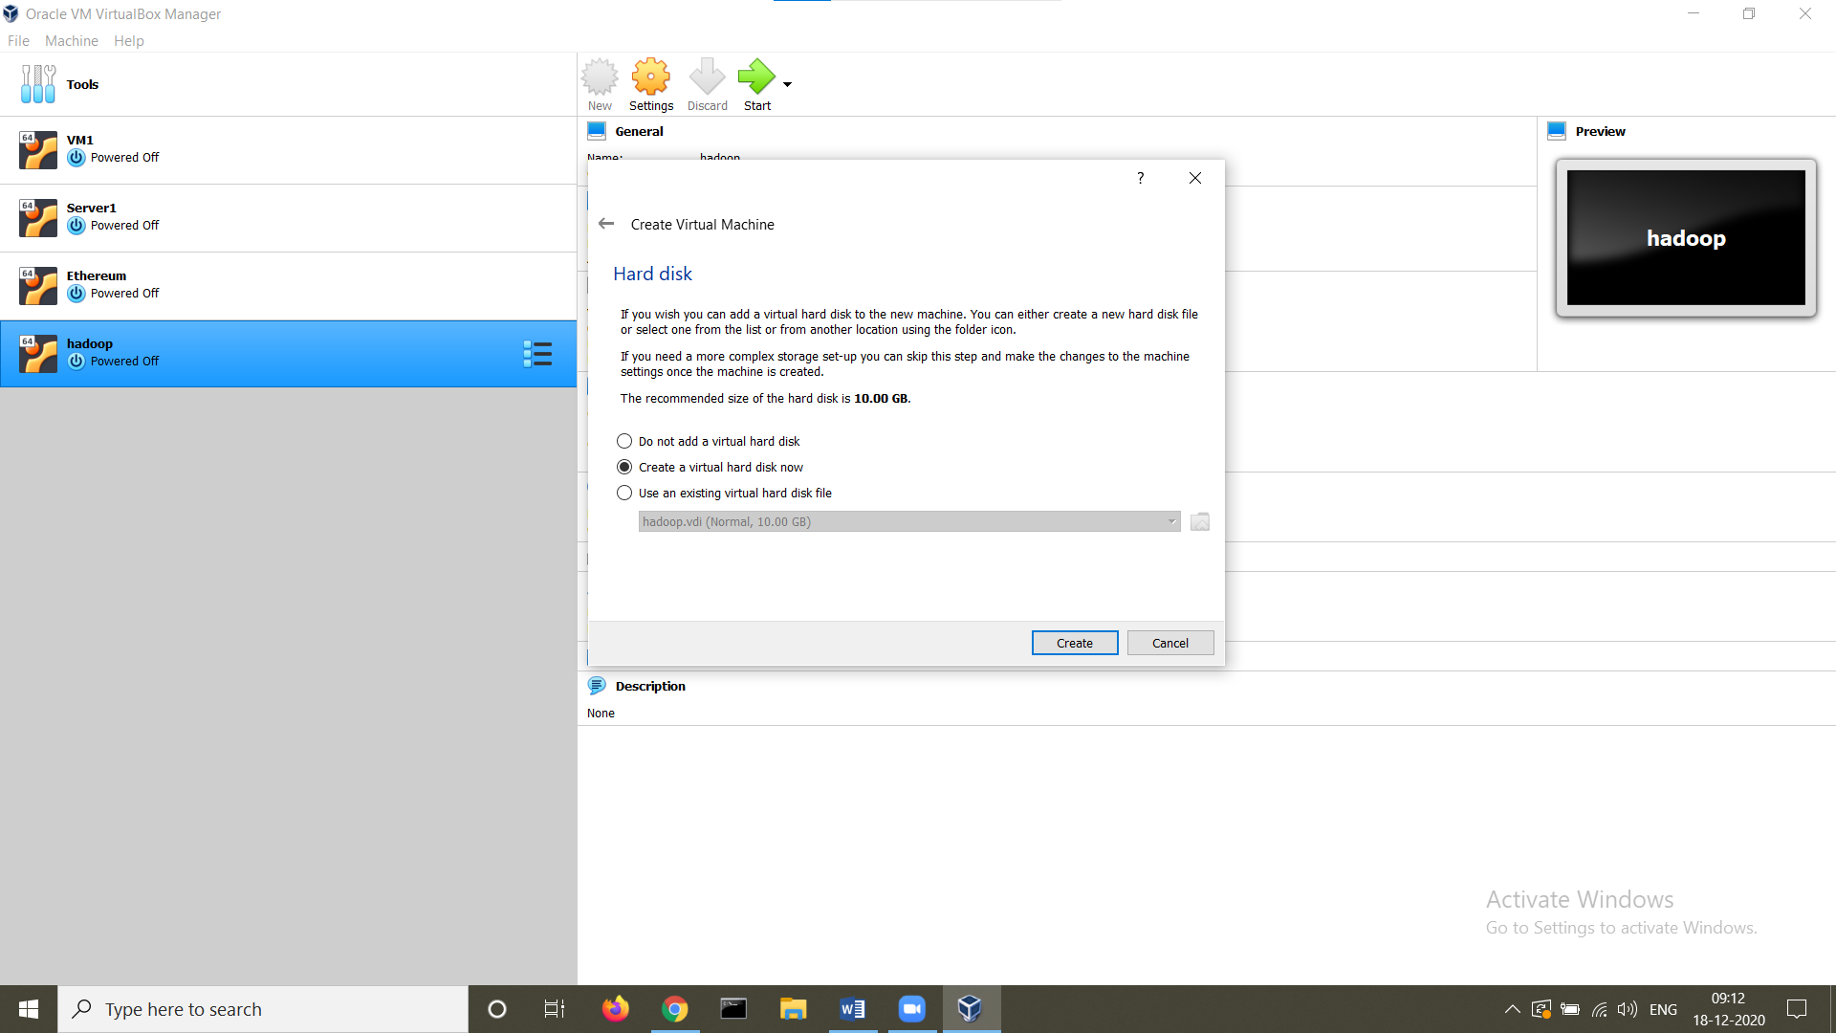

**STEP 4:** Set hard disk type

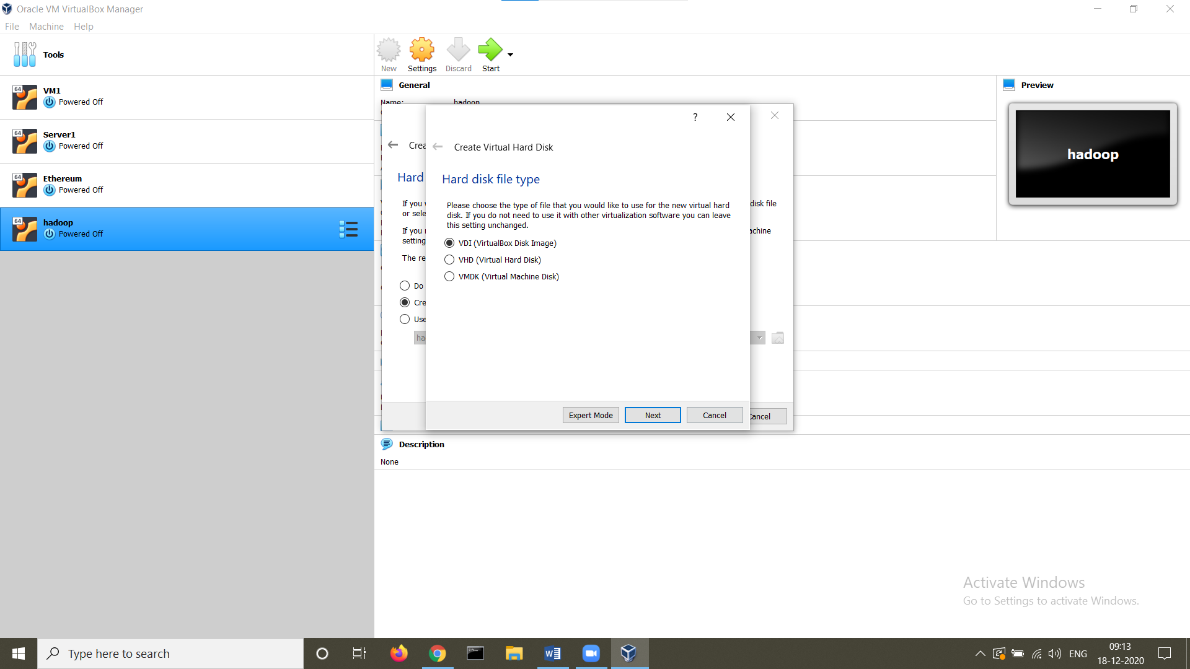

**STEP 5:** Dynamically allocate storage

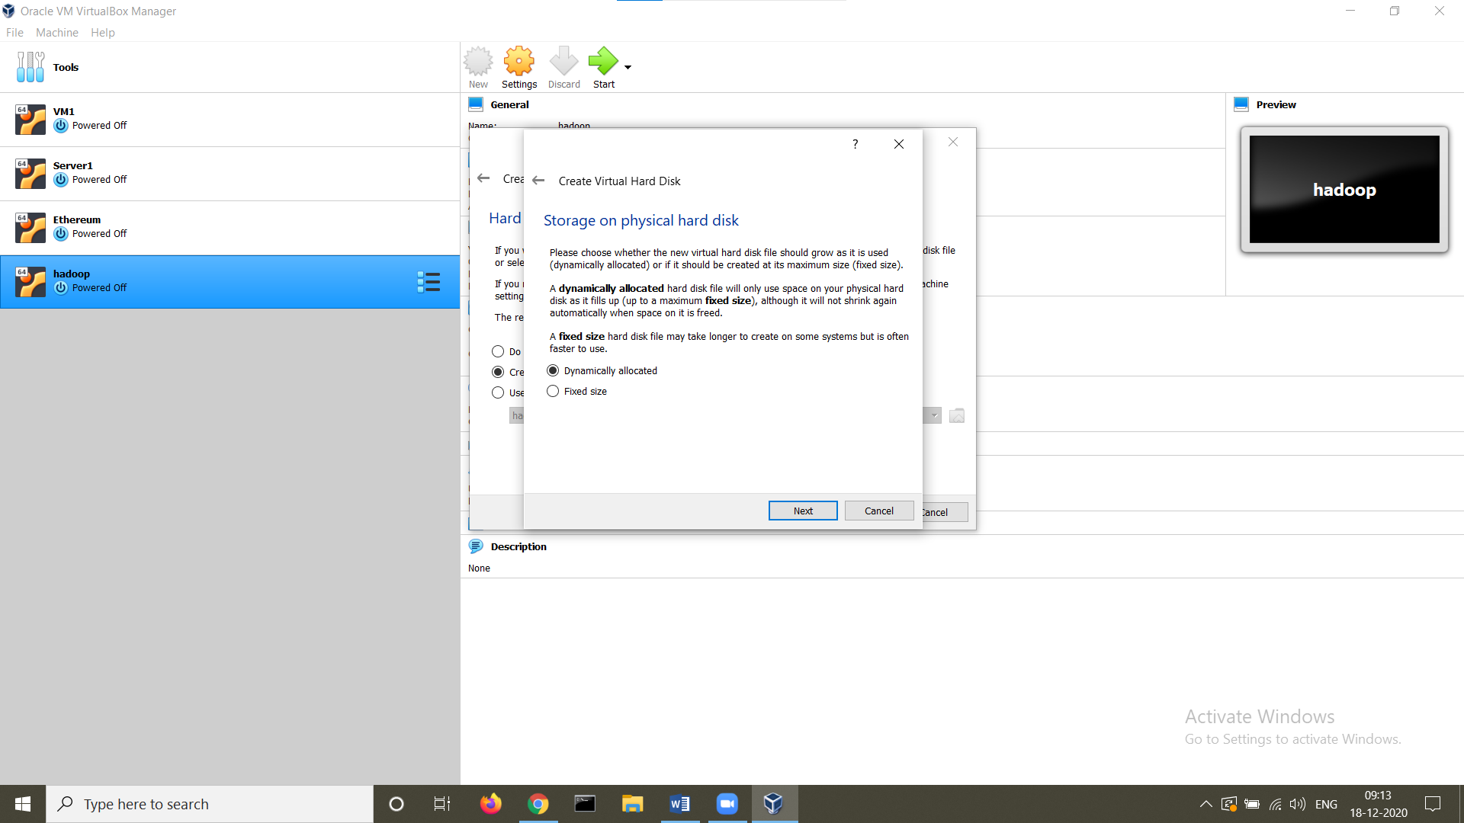

**STEP 6:** Set the hard disk size to 10 GB

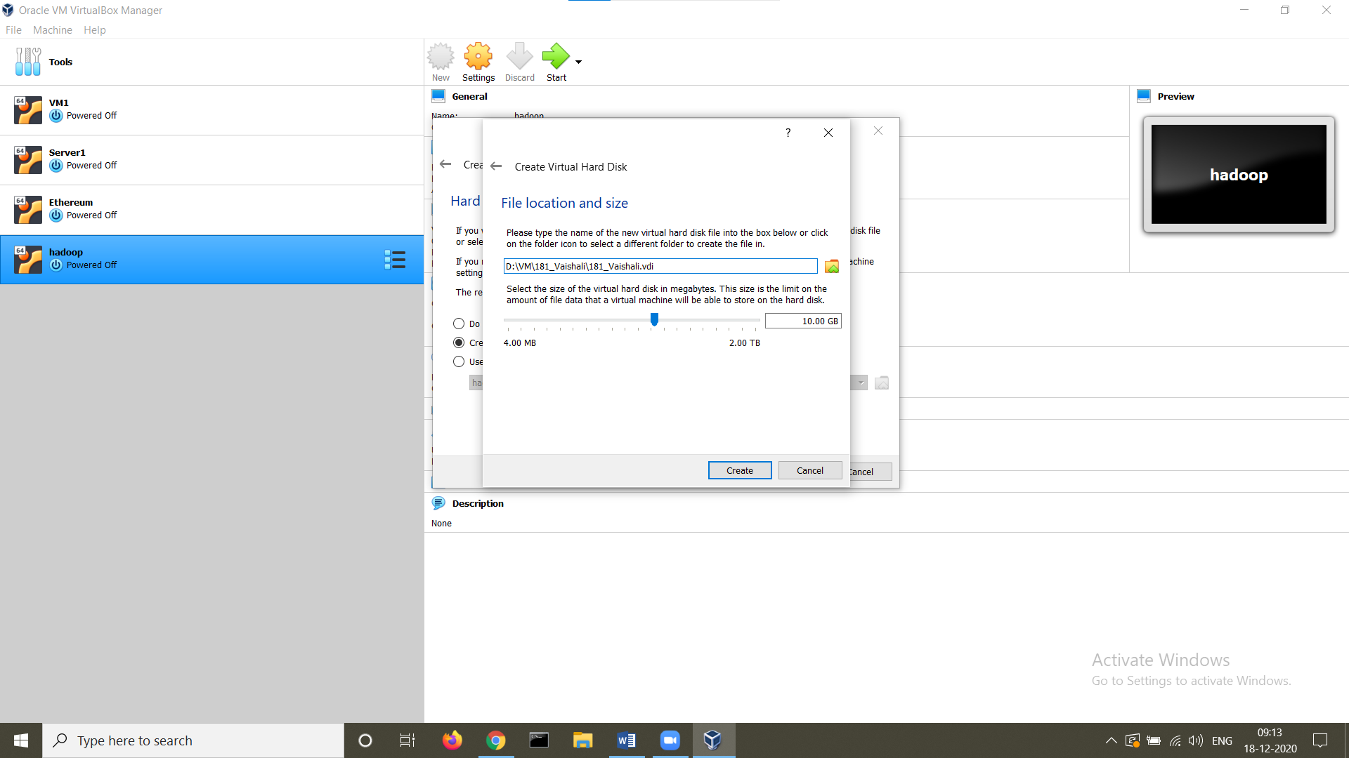

**STEP 7:** Set shared clipboard and drag n drop to bidirectional

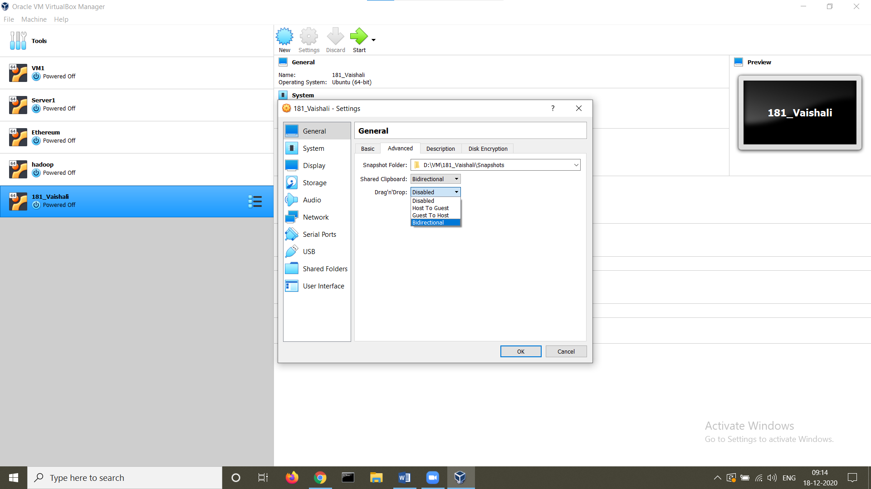

**STEP 8:** Let the network adapter be NAT

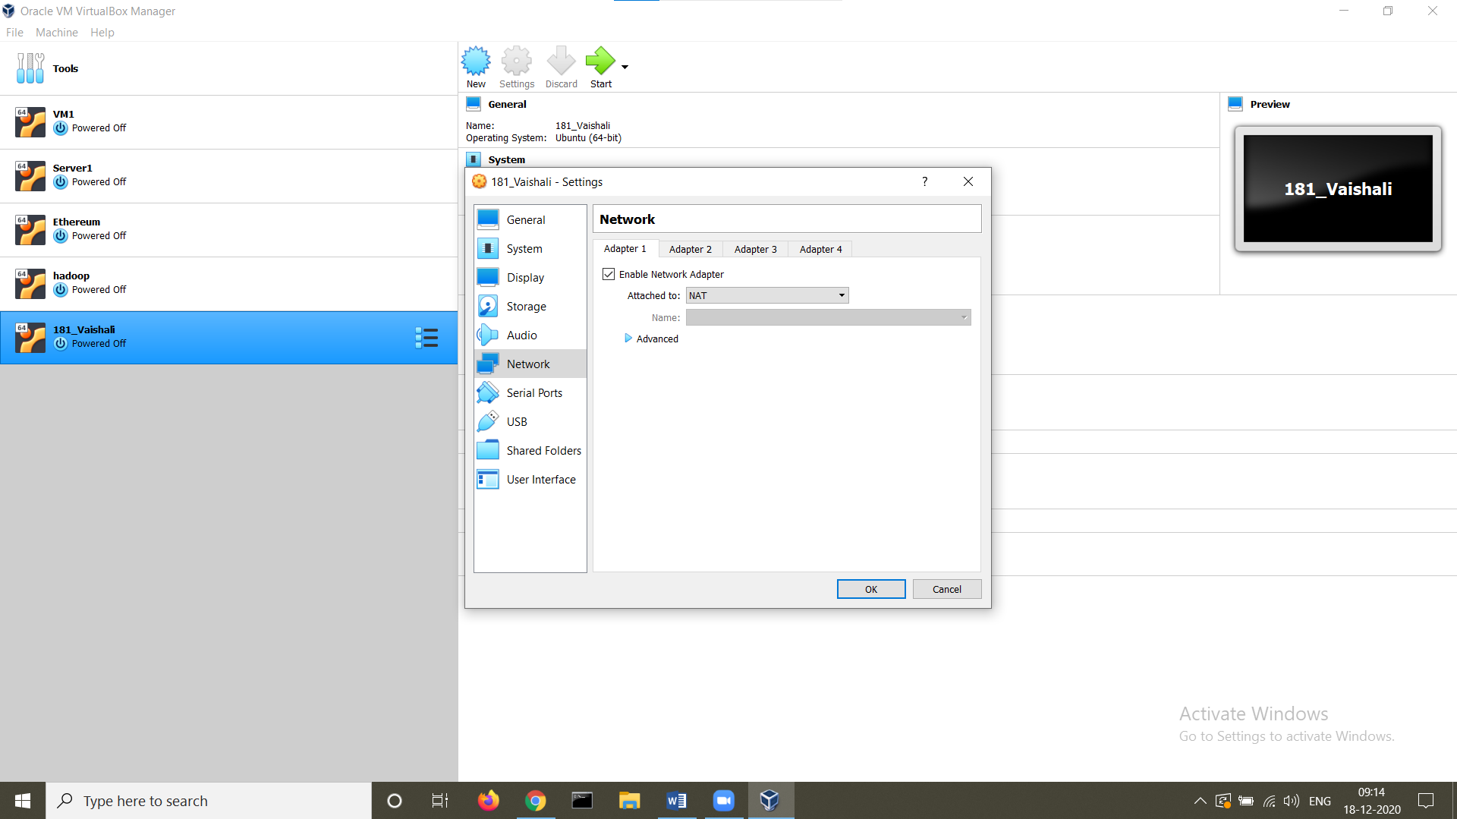

**STEP 9:** Select the ubuntu iso image

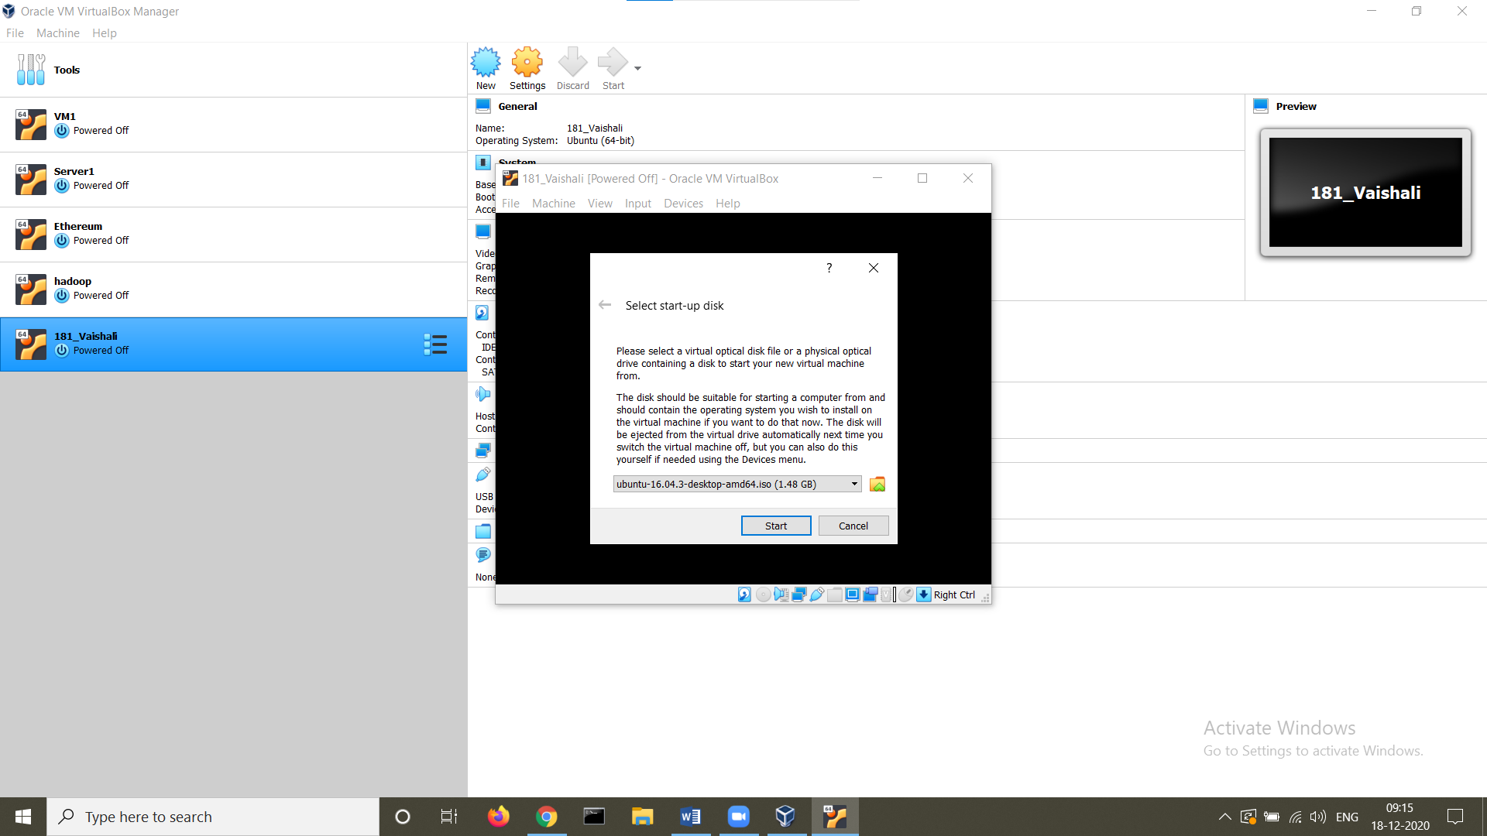

**Step 10:** Click on install Ubuntu

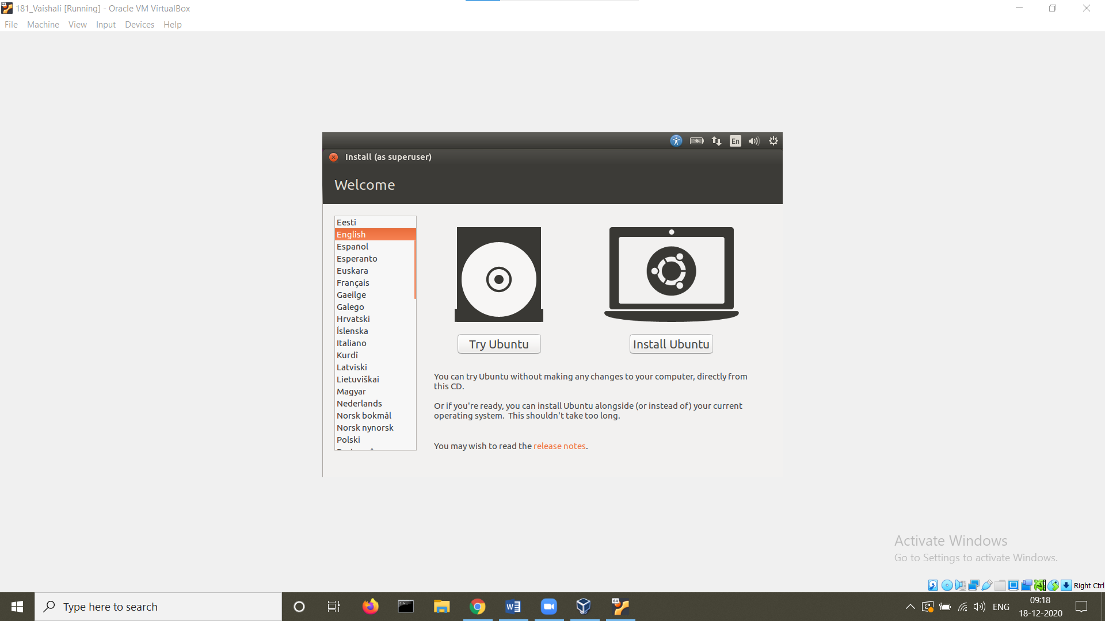

**Step 11:** Select download updates while installing Ubuntu and the installation type

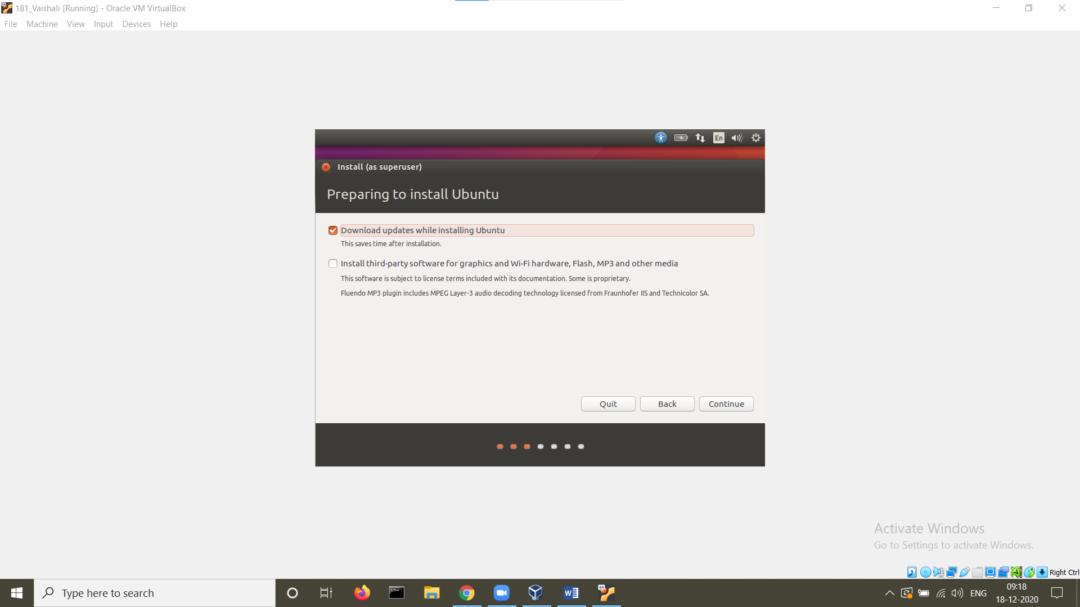

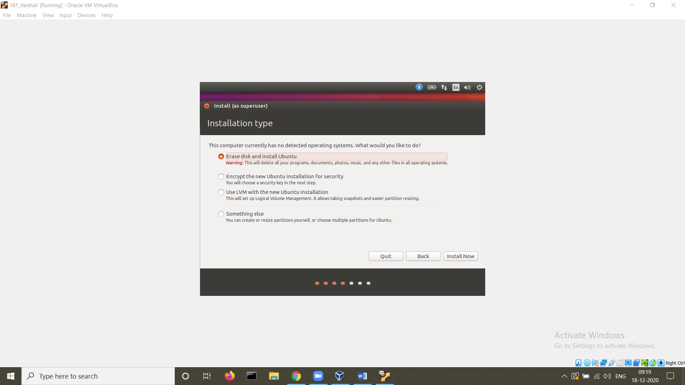

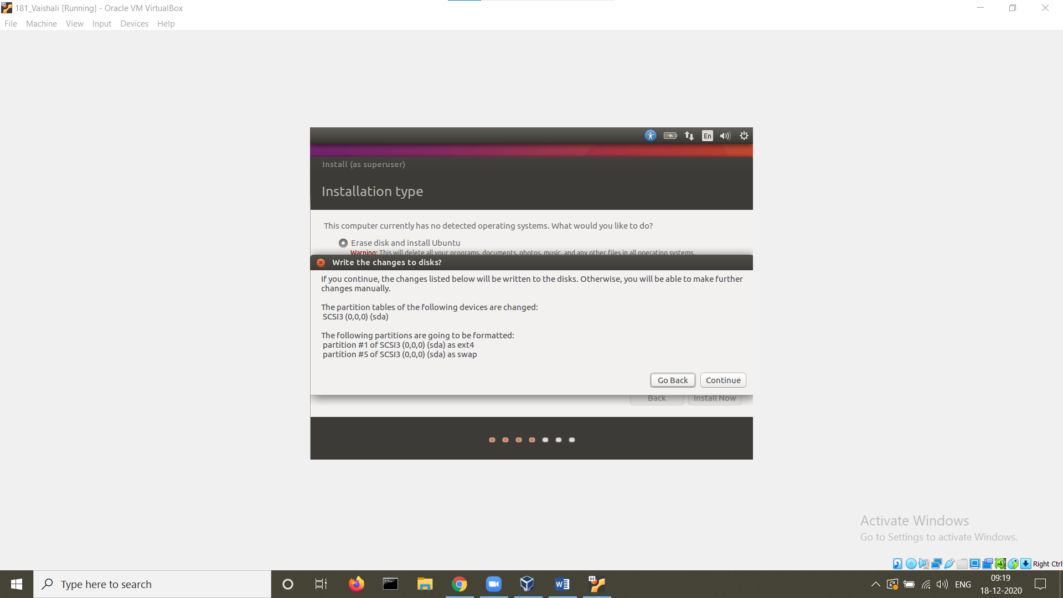

**STEP 12:** Confirm the location displayed

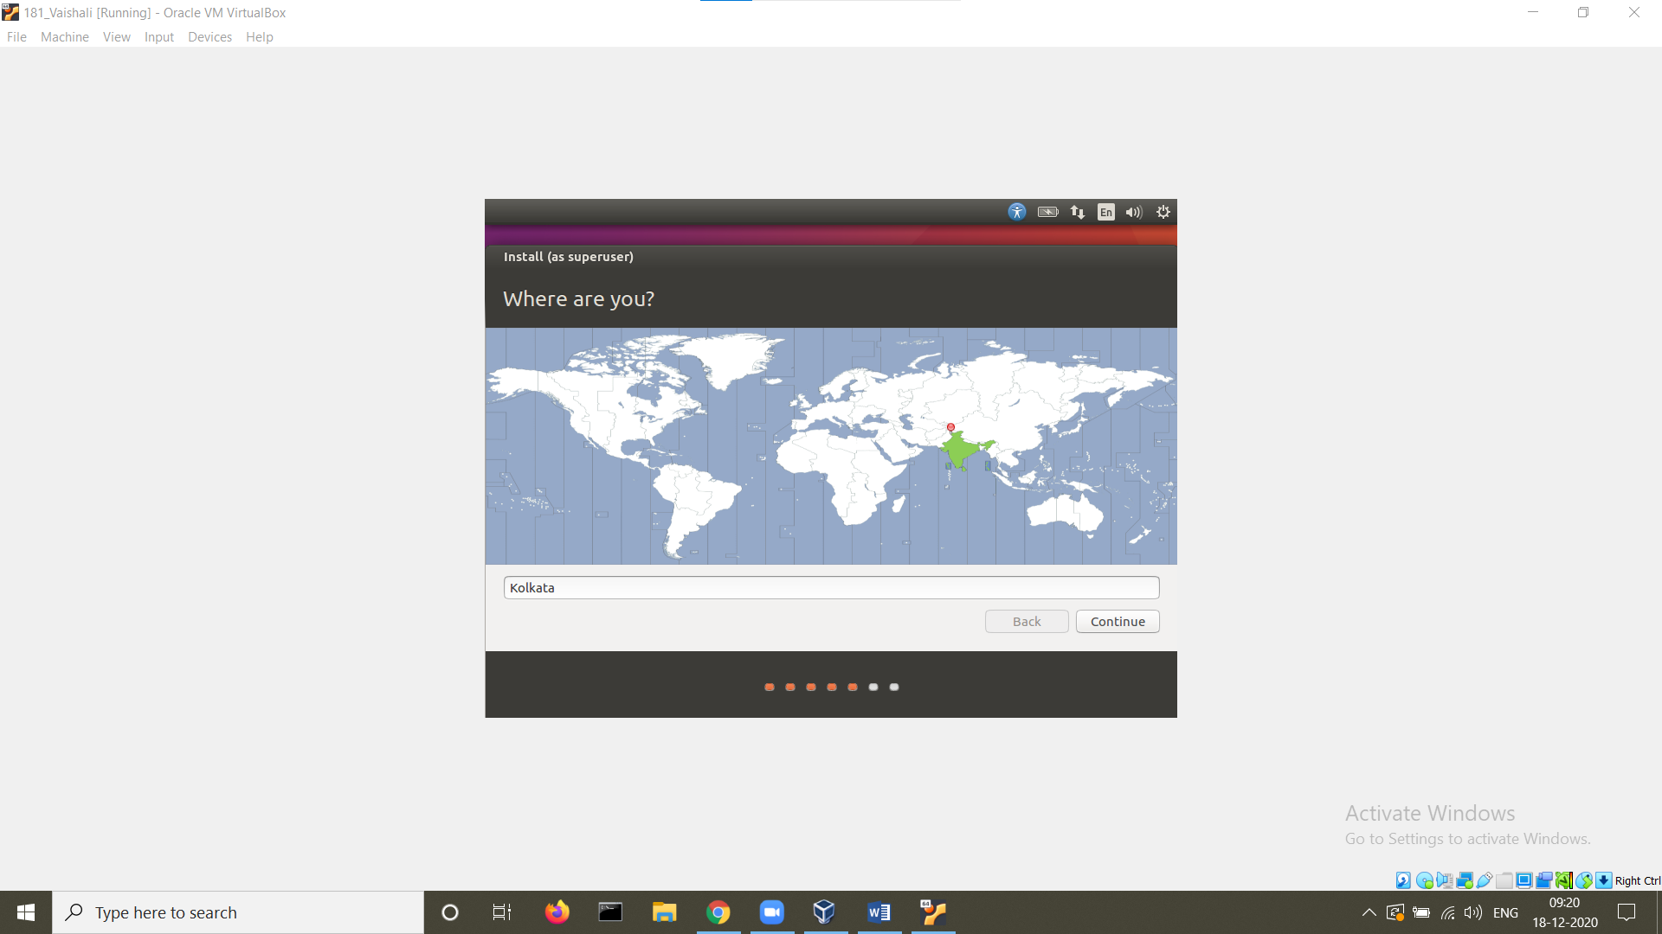

**STEP 13:** Select the keyboard layout

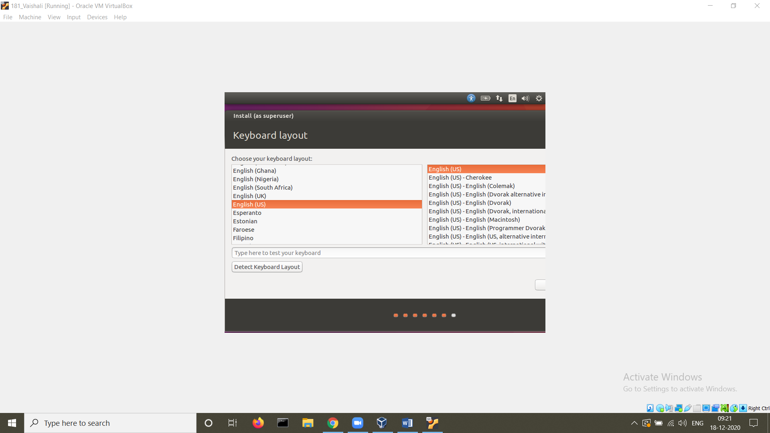

**STEP 14:** Set the name, computer’s name, username and password

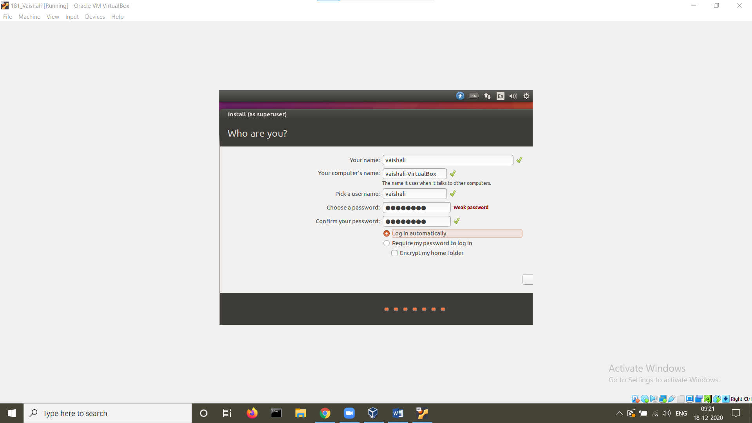

**STEP 15:** Once the installation is complete, restart the machine.

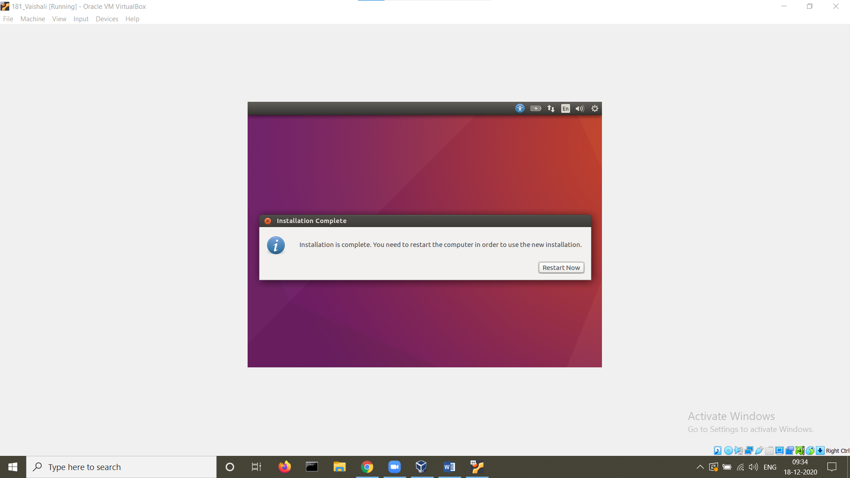

**STEP 16:** View the ip addess of the machine using the command ifconfig

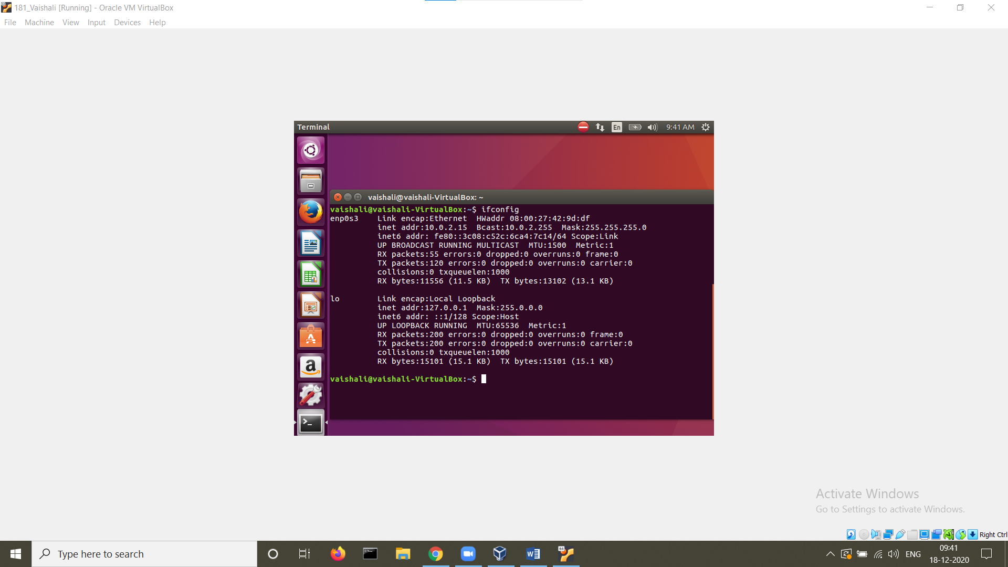

**STEP 17:** Install the jdk

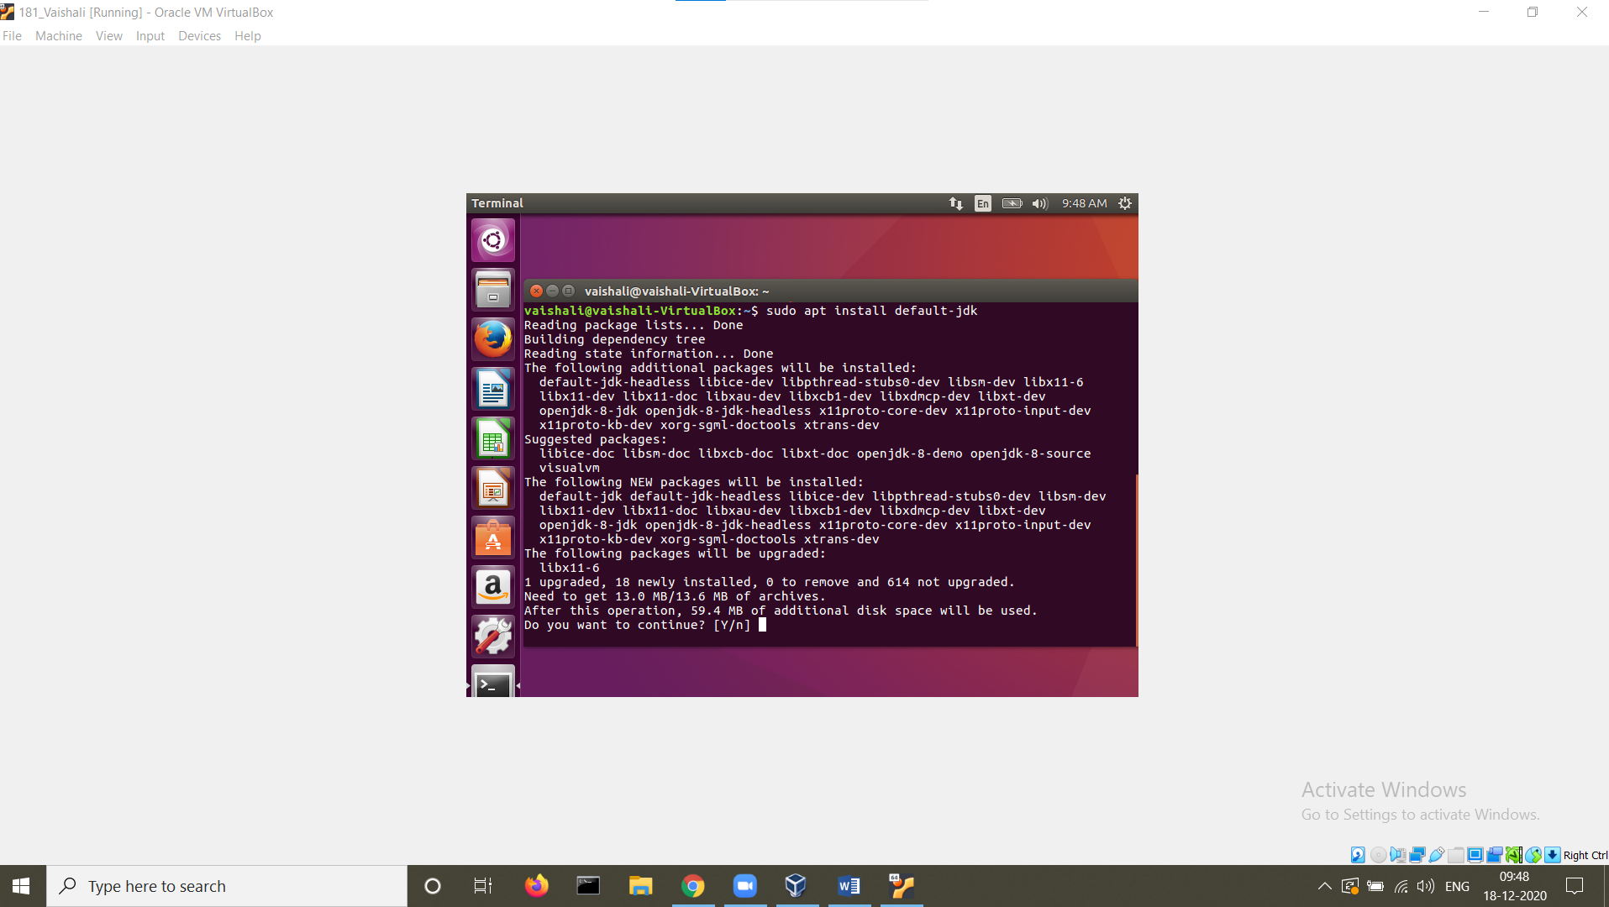

**STEP 18:** Install the jre

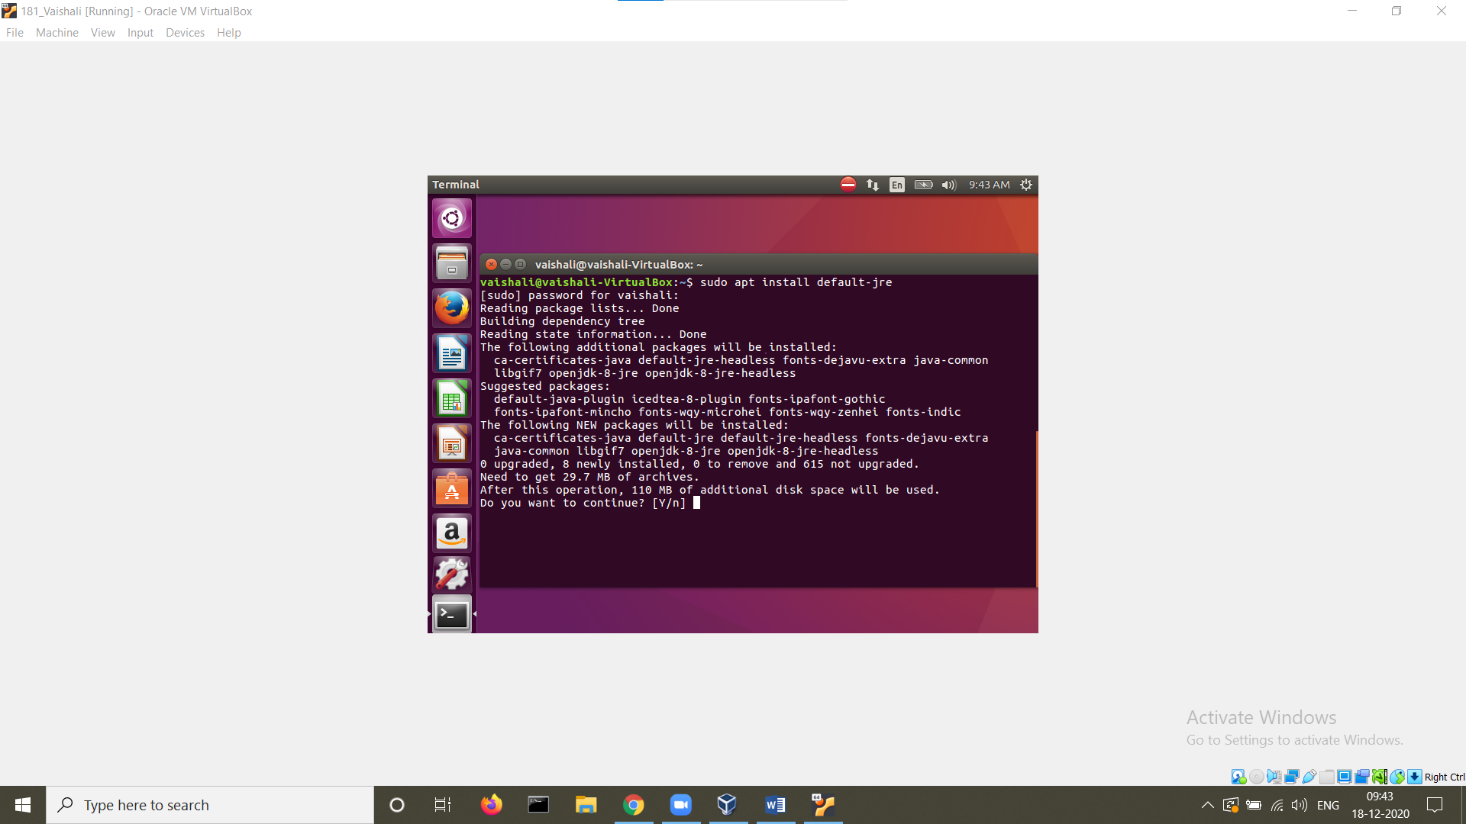

**STEP 19:** Check the version

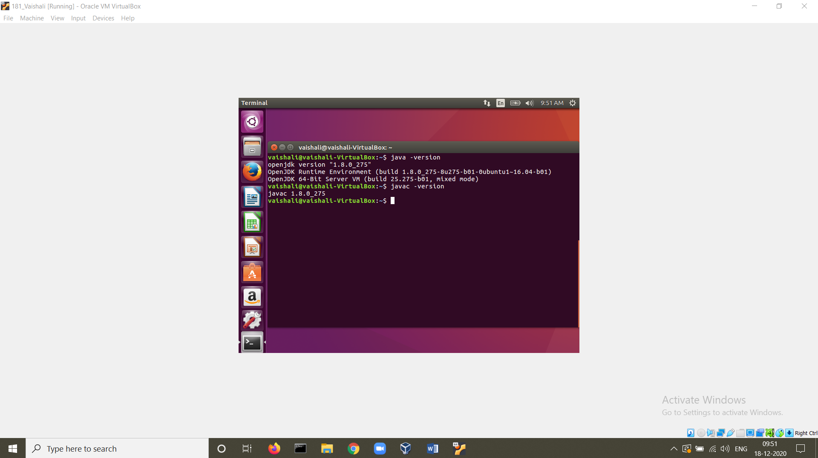

**STEP 20:** Create a new file Hello.java

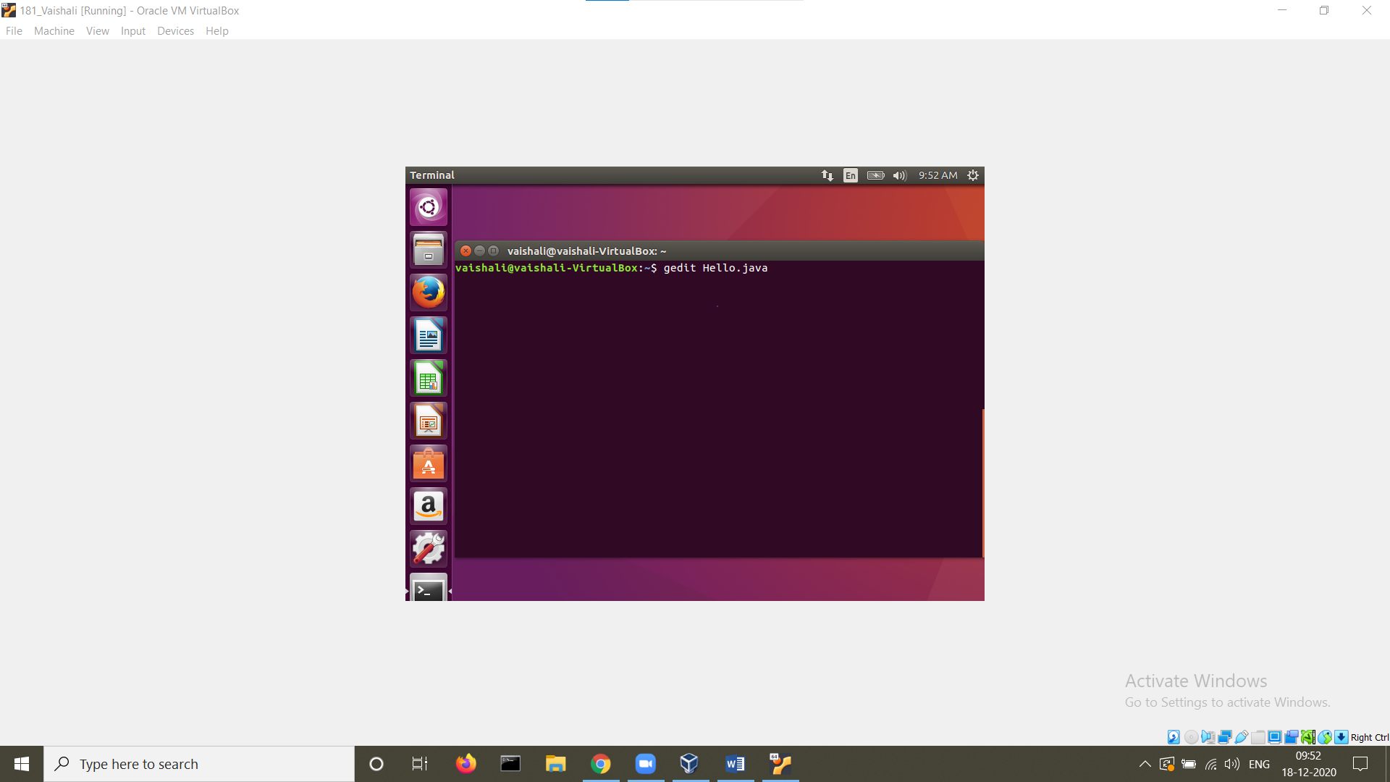

**STEP 21:** A java program to display Hello World is written

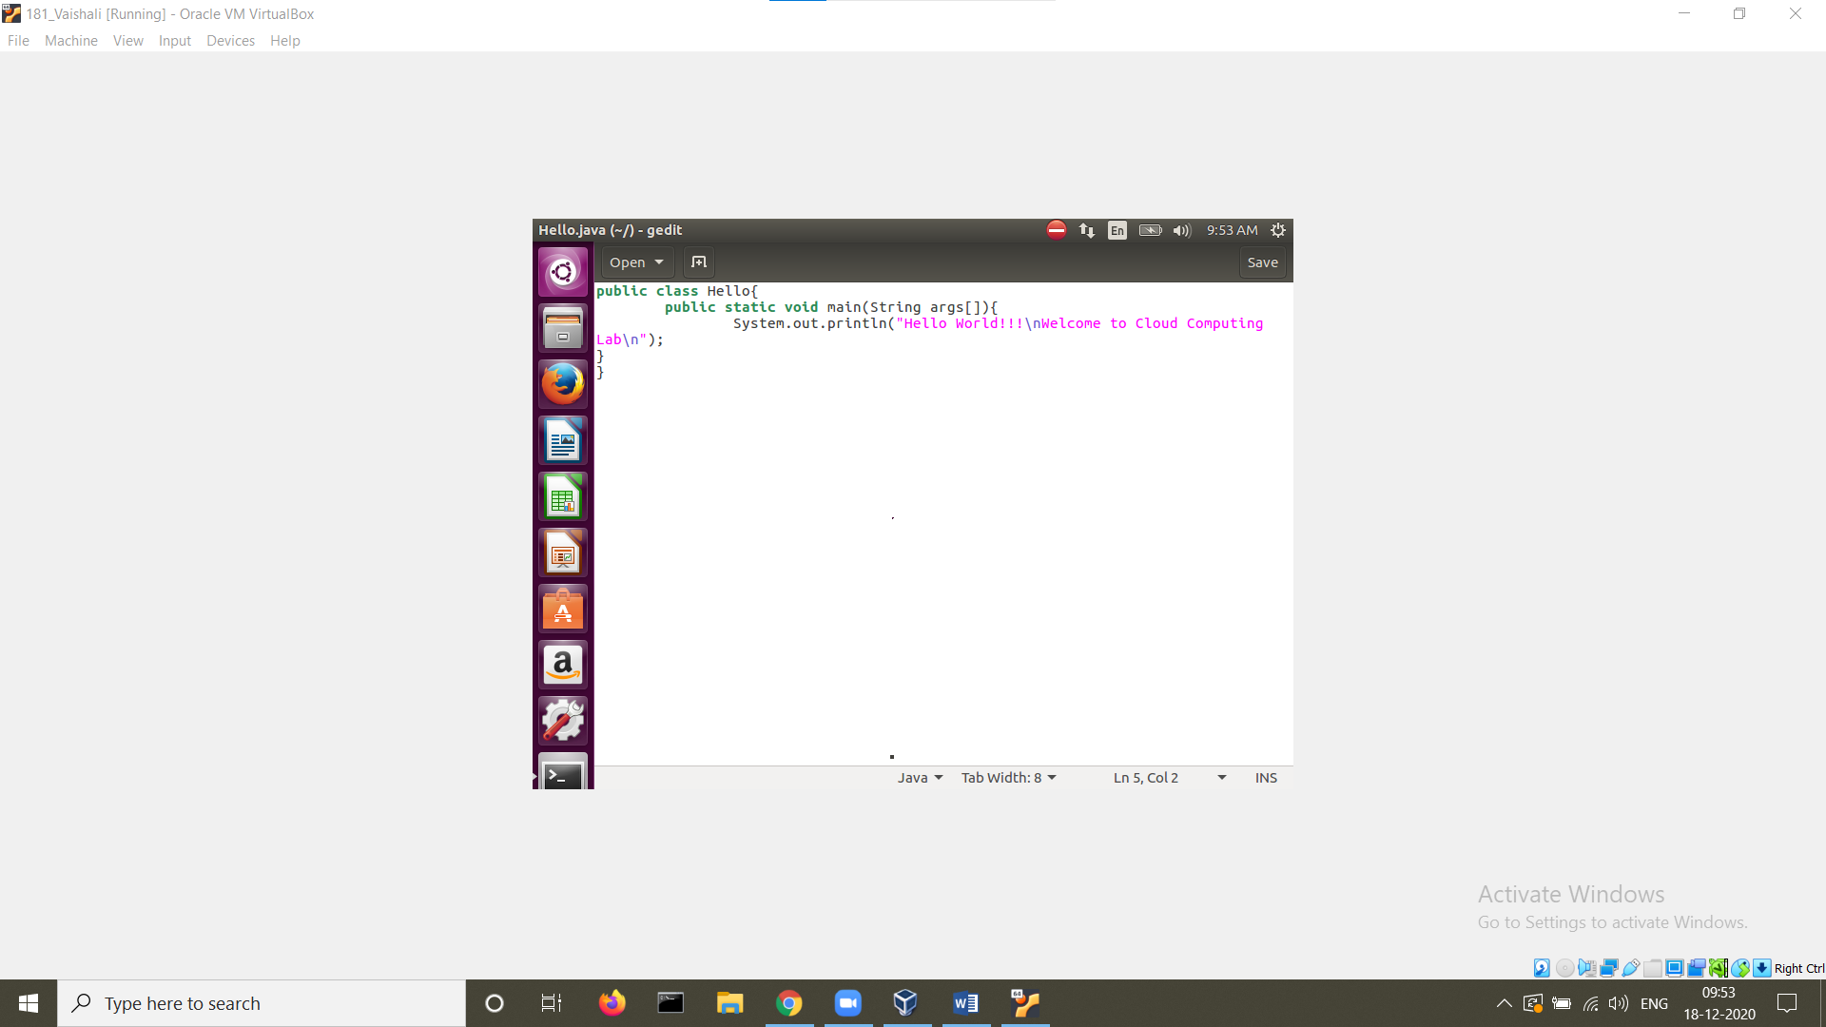

**STEP 22:** The java program is compiled and executed.

